tABLE OF cONTENTS
Chapter 1 – Awareness and Distributed Version Control Systems 2
1.1 Introduction 2
1.2 Distributed Version Control Systems 3
1.3 Branching in DVCS 4
1.3.1 Cloning a repository 6
1.3.2 Fetching from a remote repository 7
1.3.3 Anonymous branches 8
1.4 Related Work 9
1.4.1 Commit Notification 10
1.4.2 Awareness of Concurrent Changes 10
1.4.3 Repository Visualization 15
1.5 Final Considerations 19

– Awareness in Distributed Version Control Systems

Introduction
SCM is part of the Software Engineering and was born in the 70s (ESTUBLIER, 2000). According to (MURTA, 2006), under the development perspective, SCM is divided into three main systems: Change Management, Version Control, and Release Management. Change Management is in charge of systematically controlling the configuration, storing and reporting the information produced along the change requests. Version Control deals with the identification and evolution of configuration items (CI). Finally, Release Management automates the process of building executable files from the source code and releasing them into production.
Version Control Systems (VCSs) date back to the 70s, when the first VCS, called Source Code Control System (SCCS), emerged (ROCHKIND, 1975). VCSs were the first SCM systems to emerge and, since then, they have evolved substantially, from the local access needed by SCCS, to a client-server architecture, and more recently to a distributed architecture. Besides their original scope, they have also been used as a data source to mine data related to software development, because they have the knowledge of all CIs and how they evolved over time (what was changed, why changes occurred, when changes happened, and who performed the changes). Moreover, as VCSs are the single point where every IC resides, they might be used not only to know what happened in the past, but also provide awareness of what is happening in the present and to help predicting what might happen in the future.
Awareness is defined by (DOURISH; BELLOTTI, 1992) as “an understanding of the activities of others to provide a context for one’s own activities”. The information needed to provide awareness depends on what people need to be aware of. In the context of this work, which focus on the awareness of changes occurring in DVCS, all the information needed is generally available within the repository, such as which files have changed, what changes were applied, who applied the changes, when the changes occurred, and why the changes were applied.
This chapter presents some basic concepts related to DVCS and some approaches related to providing awareness combined with VCS. Section 1.2 discusses central concepts regarding how DVCS work. Section 1.3 presents related work. Finally, Section 1.4 presents the final considerations of this chapter.

Distributed Version Control Systems
CVCS relies on a centralized repository, stored on a server (Figure 1.a). When someone wants to work on any CI, a checkout is performed, copying a specific version of the artifacts from the repository to a workspace where changes can be applied. Later, after applying the changes, a commit (also known as check-in) is performed, sending all the changes back to the repository. Updates made by other developers can be brought to the workspace at any time, by performing an update. Updates are automatically merged into workspace, or, in the case of physical conflicts (same part of the artifact changed locally and remotely), the developer might have to handle the merge manually.
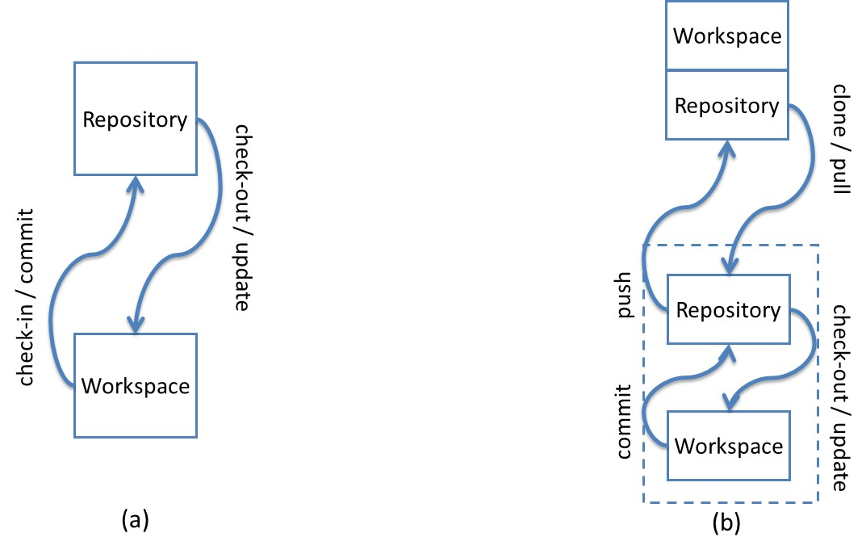
Figure 1 – CVCS (a) versus DVCS (b)
DVCS, on the other hand, does not rely on a centralized repository. It uses an architecture where the entire repository is distributed and exists in every machine where someone wants to work with it. The changes continue to take place on a workspace, but there is a local copy of the repository attached to the workspace (Figure 1.b). The main operations (checkout, commit, and update) continue to exist, but are performed locally, allowing offline work, committing whenever necessary. However, another set of commands arises, which allows sending and receiving changes between different repositories. Initially, a clone is performed, copying the repository from a specified location. The copy can be done from a repository located on a partner or on a server. We will refer to the original repository as remote repository. There is no concept of a central repository, but some repository may act as a central repository by having, for example, a strict policy regarding who might send changes to it. Repositories might either have an associated workspace or not. A repository located on a server, where local changes are not expected to occur, does not need to have a workspace associated, and is referred as a bare repository. A bare repository is just like a regular one, except that it does not have a workspace associated with it. Due to the lack of a workspace associated, commands that depend upon a workspace (commit, update, and merge) cannot be performed on a bare repository. Changes can be sent from a local repository to a remote repository by invoking a push command. Changes can be received from remote repositories and applied immediately to the workspace, leading to merges / conflicts, or they can stay at the local repository to be applied later. A pull command brings the changes and applies them to the workspace. A pull can be broken into two subcommands: a fetch command, that only transfers the changes to the local repository, without applying them to the workspace, and a merge command, which applies the changes to the workspace.

Branching in DVCS
The commits performed in a repository are based on previous commits, thus forming a directed acyclic graph (DAG), where newer commits point to older commits. Figure 2 represents a repository with three commits. Commit “3” is pointed by a label named master. As new commits arise, the master pointer moves accordingly. This way, if we want to refer to the last commit in this repository, we do not need to know how many commits there are. All we have to do is ask for the master commit.
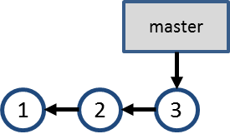
Figure 2 – Commits in a repository
This linear development is not frequent in real repositories, for a number of reasons, such as supporting multiple releases of the same software, trying new technologies that might be included in future versions or fixing multiple bugs in parallel. In such cases, it is common use branches, which are, according to (LEON, 2004), “a deviation from the main development line for an item”.
Suppose that a bug is found in a software product during tests. The test team creates issue 55, asking the development team to fix the bug. The development team verifies that the software version being tested corresponds to commit #3, but the bug will take a considerable time to be fixed and the development cannot stop waiting for the bug fix. A branch named “issue55” is then created, pointing to commit #3 (Figure 3.a). At this moment, development can occur in parallel, with commits #5 and #7 being made to branch “issue55” and commits #4 and #6 being made to branch “master” (Figure 3.b). Finally, the team decides to merge the fix to issue #55 into the “master” branch, generating commit #8 (Figure 3.c).
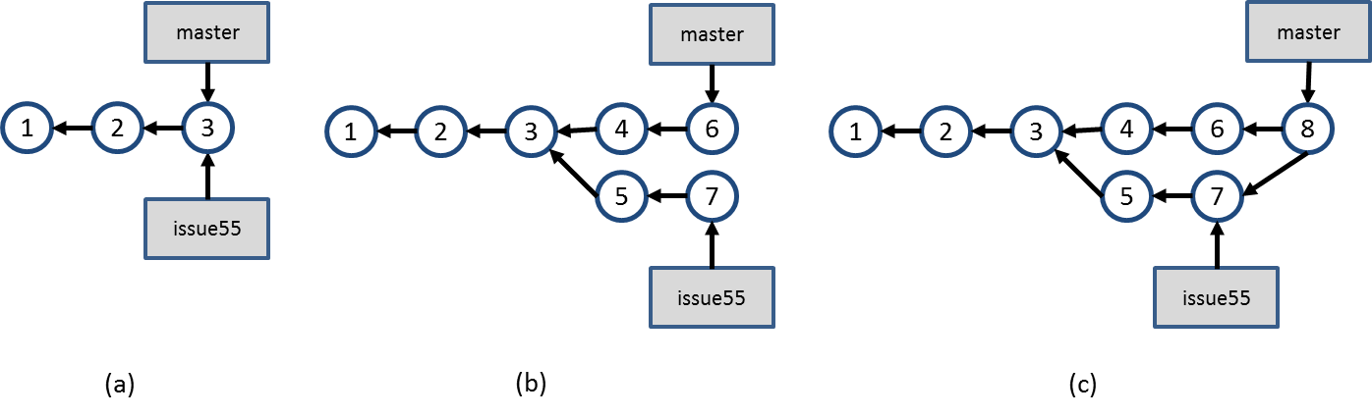
Figure 3 – Branch “issue55” is created and development occurs in parallel
This is a scenario where we experience the usage of explicit branches, i.e., a scenario where one explicitly creates a branch to perform some work. However, when using DVCS, there are other situations where branches arise implicitly. In these situations, one does not explicitly asks to create a new branch, but the branch concept is used anyway. We refer to branches that are no created explicitly as implicit branches. The next sections will show some situations where this occurs.

Cloning a repository
Suppose a repository like the one shown in Figure 2. At this point, clones A, B, and C are created by different developers, as shown in Figure 4, where the first three commits are the same in all of them, but other As discussed in Section 1.2, each clone is a complete repository copy, independent from the other clones, enabling parallel development. We thus can see each clone as a fork of the original repository. The colors in the commits are used to identify the clone where that commit was originally done. The numbers identifying each commit are used for the sake of this example, but commits are not necessarily identified by a sequential number. For example, in Git, commits are identified by a hash code of 40 hexadecimal digits.
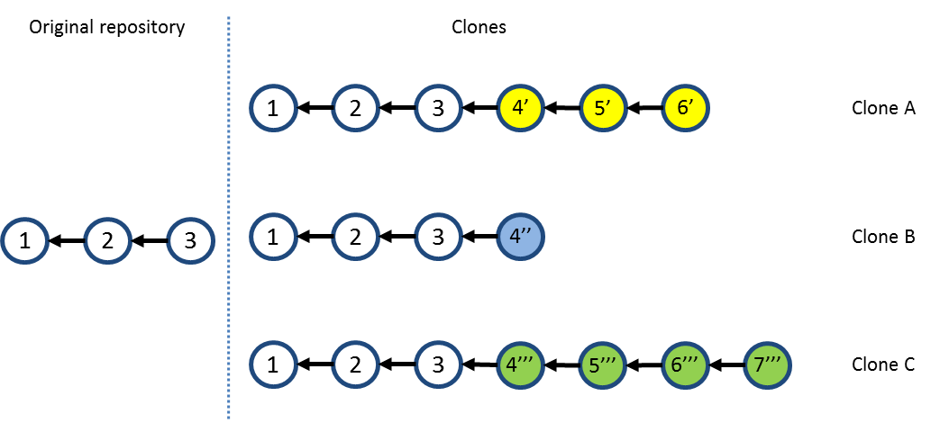
Figure 4 – Branching through cloning
The first clone to push changes to the original repository is be able to do it with no extra work. Let us assume that clone A is the first one to push its changes to the original repository. This results in a scenario like the one shown in Figure 5.
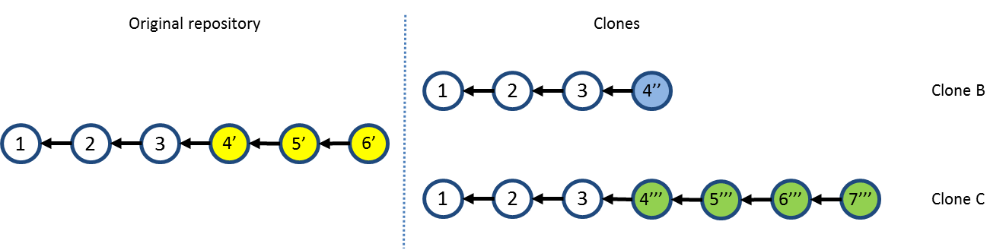
Figure 5 – Repositories after pushing changes from clone A
Next, clone B tries to push its changes to the original repository, but this not allowed, because it could result in inconsistencies in the VCS, once commits from clone A were never tested together with commits from clone B. To allow clone B to push its changes, it is necessary to first pull commits 4’, 5’ and 6’ from the original repository, merging them in the clone B workspace, resulting in the scenario shown in Figure 6. Notice that, in this case, there is an additional commit, denoted by 5’’.
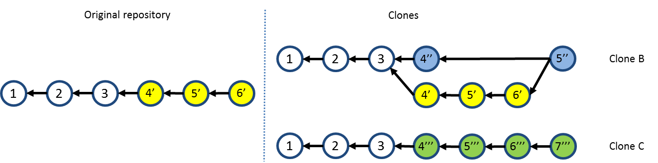
Figure 6 – Repositories after merging work from clone B.
Clone B then push its changes, resulting in the scenario shown in Figure 7. Finally, clone C has to follow the same procedure, i.e., pull the changes previously pushed by clone A and clone B and merge them into its workspace, resulting in the scenario shown in Figure 8.
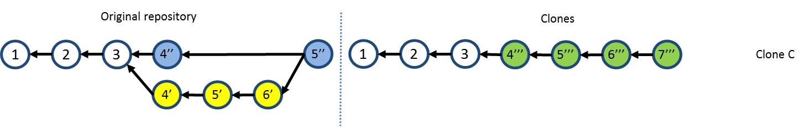
Figure 7 – Repositories after pushing changes from clone B
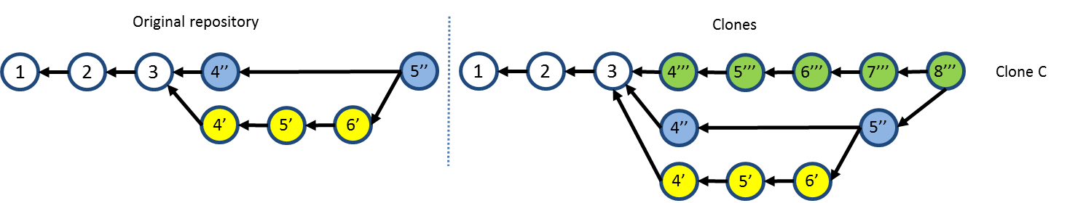
Figure 8 – Repositories after merging work from clone C

Fetching from a remote repository
In the previous section, before pushing changes to a repository that has received pushes from other peers, we explained that one should pull the recent changes, merging them into his workspace. However, one could choose to bring the changes without immediately merging them. This is accomplished by only fetching the updates. If clone B had opted to only fetch updates from the original repository, this would result in a branch, as shown in Figure 9. Here, branch master is the local branch in clone B, and branch origin/master is the master branch from the original repository.
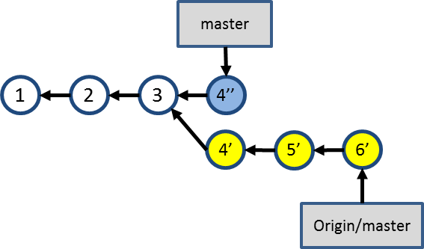
Figure 9 – Branch after fetching updates from the original repository
This brings new concept regarding branches: tracking and non-tracking branches. A non-tracking branch is a local branch that is not shared with peers. A non-tracked branch exists only in the local repository and it is not pushed to remote repositories. On the other hand, a tracking branch is a branch that one chooses to share with peers, by associating a local branch with a branch in the remote repository. In the example shown in Figure 9, we say that local branch master tracks branch master in the remote repository. This way, when one pushes to a remote repository, the remote branches are updated to point to the correct commits. The result is shown in Figure 10. Notice that both the local and the remote branches are updated to point to same commit.
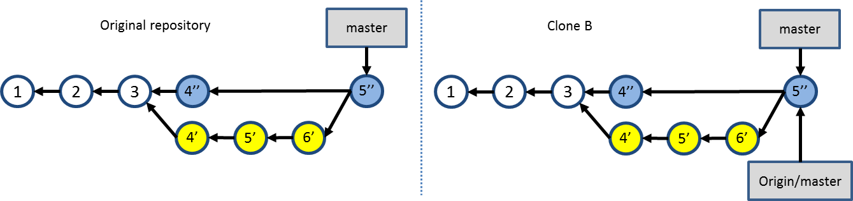
Figure 10 – Result of pushing changes from a tracked branch.

Anonymous branches
An anonymous branch is a branch created when we checkout a commit which is not referenced by a branch. When this happens, commits are performed in the same way, pointing to their predecessors, with the difference that there is no branch pointing to them (see Figure 11). This way, if one chooses to work with another branch after committing on an anonymous branch, these commits will be accessible only through their internal identifications generated by the VCS.
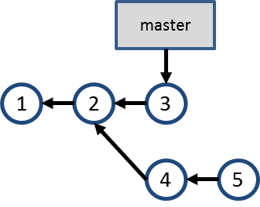
Figure 11 – Anonymous branch

Related Work
According to (DIEHL, 2007), software visualization can be separated into three aspects: structure, behavior, and evolution. DyeVC relates primarily with the evolution aspect, more specifically with studies that aim at improving the awareness for people that work with distributed software development. A recent work by (STEINMACHER; CHAVES; GEROSA, 2012) presents a systematic review of awareness studies and classify them according to the Awareness Framework (GUTWIN; GREENBERG; ROSEMAN, 1996) and according to the 3C Collaboration Model (FUKS et al., 2007). The classification is not exclusive, i.e., a given tool can present elements of different awareness types. According to (GUTWIN; GREENBERG; ROSEMAN, 1996), DyeVC can be classified as a “Workspace Awareness” approach and according to (FUKS et al., 2007), DyeVC fits into the “Coordination” and “Cooperation” categories.
This section describes some approaches related to awareness or visualization of information stored in VCSs. We used a criterion similar to snowballing sample (GOODMAN, 1961) to select the approaches, starting with a finite individual population as a seed and looking for these approaches’ citations and at approaches that cited them. Our initial seed was based on the referenced papers analyzed by (STEINMACHER; CHAVES; GEROSA, 2012). We also searched at the main academic digital libraries (ACM, IEEE, SpringerLink and ScienceDirect) and at the industry, using the keywords “revision”, “source code”, “software configuration”, “source control”, “version control”, “application” and “system”, combined with “awareness” and “visualization”. We filtered the results found to get only studies that used VCS. The resulting studies were divided into three groups. The first group includes tools that notify commit activities. The second group comprises approaches that give the developer awareness of concurrent changes, sometimes informing them if conflicts were detected. Finally, the third group includes approaches that visualize repository information in a linear way. The next sub-sections discuss each of these groups.

Commit Notification
Under the “Commit Notification” group, we found approaches such as SVN Notifier, SCM Notifier, Commit Monitor, SVN Radar, Hg Commit Monitor and Elvin (FITZPATRICK; MARSHALL; PHILLIPS, 2006). The primary focus of these approaches is on increasing the developer’s perception of concurrent work by showing notifications whenever other developers perform actions. Figure 2 shows some of these approaches in action. We can see notifications shown by SVN Notifier (Figure 2.a), SCM Notifier (Figure 2.b), Commit Monitor (Figure 2.c) and Elvin (Figure 2.d).
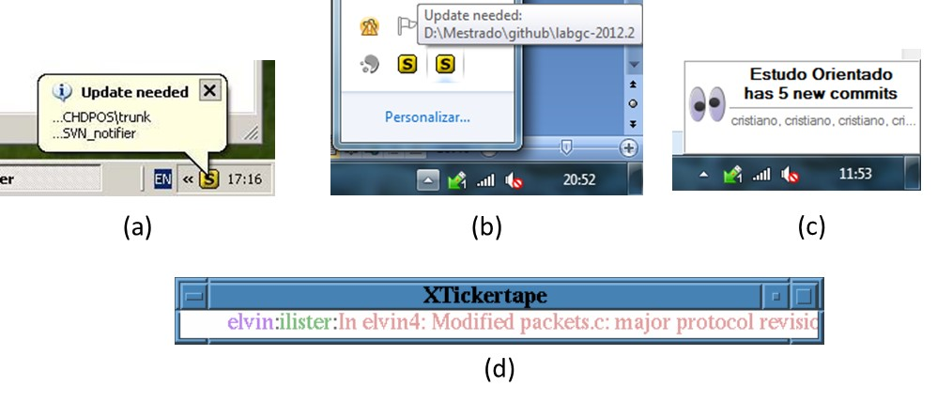
Figure 12 – Commit Notification Approaches

Awareness of Concurrent Changes
There are many approaches that propose increasing the awareness of changes across different team members. Palantir (SARMA; REDMILES; VAN DER HOEK, 2012) shares information about changes to the same files across different workspaces, showing this information as an eclipse plugin, as shown in Figure 3. The plugin shows the percentage of modification of each file, such as [S:24] in Payment.java, which indicates that 24% of the file was modified. It also indicates if there is a direct conflict (marked in the top left with a blue triangle) or an indirect conflict (red triangle in the top right). Direct conflicts are those that occur when there are changes on the same line in different workspaces. Indirect conflicts are those that occur in different lines, for example, when someone changes the signature of a method and the call to that method is not changed to incorporate the change.
Figure 13 – Eclipse window with Palantir plugin. Extracted from (SARMA; REDMILES; VAN DER HOEK, 2012)
CollabVS (DEWAN; HEGDE, 2007) is a Visual Studio plugin that identifies conflicts while code is being edited (Figure 4.a). The author can choose between just adding a watch to be notified when his collaborator finishes editing the conflicting code (Figure 4.b) and establishing a communication session with the other author (Figure 4.c).

(a)
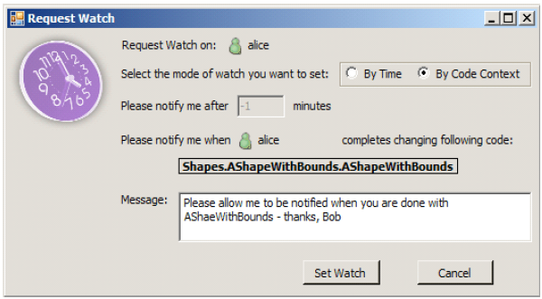
(b) (c)
Figure 14 – CollabVS snippets. Extracted from (DEWAN; HEGDE, 2007)
FASTDash (BIEHL et al., 2007) does not detect conflicts directly, but provides awareness of potential conflicts, such as two programmers editing the same region of the same source file (direct conflicts), in repositories stored in Team Foundation Server. The notifications can be presented in a visualization runtime as a plugin to Visual Studio. Figure 5 shows FASTDash Visualization Runtime. According to the authors, FASTDash was designed for agile project teams of 3-8 developers, which makes it inappropriate to be used in large projects.
Figure 15 – FASTDash Visualization Runtime. Extracted from (BIEHL et al., 2007)
Lighthouse (DA SILVA et al., 2006) is an Eclipse plug-in that monitors workspaces for changes as soon as they are made, in order to address conflicts sooner. It presents an up to date design (Figure 6) indicating where the changes have been made and by whom, as well as if these changes have already been propagated to the repository and to other workspaces.
Figure 16 – Lighthouse plugin on Eclipse. Extracted from (DA SILVA et al., 2006)
WeCode (GUIMARÃES; SILVA, 2012) is an eclipse plugin for real-time integration of changes, which is accomplished by means of continuously merging work done by other team members. Figure 7 shows the plugin in action. The Team view (3) shows the members of the team, along with their changes. The Team Merge view (4) shows the conflicts that arise during continuous merge. The Package Explorer (1) and the Source Code view (2) were adapted to indicate existing conflicts.
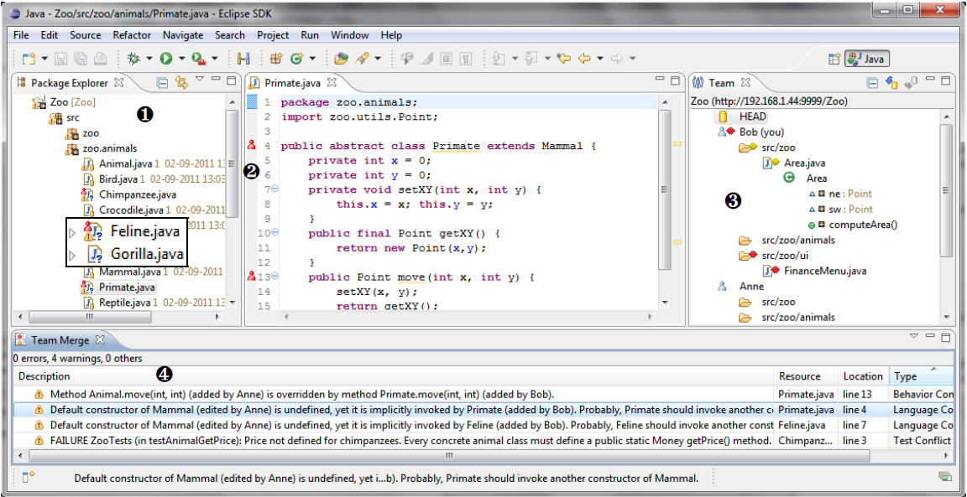
Figure 17 – WeCode continuous merging. Extracted from (GUIMARÃES; SILVA, 2012)
Crystal (BRUN et al., 2011) performs background merges between pairs of repositories, compiling and testing the merged code, resulting in “merge failure”, “compilation failure”, “tests failure”, or “tests passed” (Figure 8).
Figure 18 – Crystal snapshot. Extracted from (BRUN et al., 2011)

Repository Visualization
Repository visualization consists in taking the information stored in VCSs and present it in a visual way. A number of approaches exist that propose different visualizations with different focuses. Gevol focuses on program structures. It extracts information about a Java program stored in a CVS version control system and displays it using a temporal graph visualizer. Figure 9 shows an example of a call graph, where nodes start out red, and in the case that no changes exist they turn purple and then blue. When a change is performed, the affected nodes turn red and the cycle starts again.
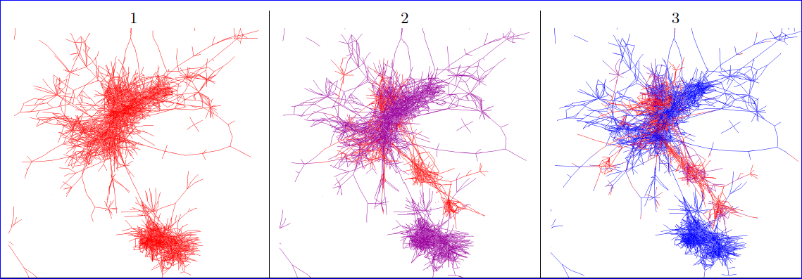
Figure 19 – Gevol: focus on program structures. Extracted from (COLLBERG et al., 2003)
The Evolution Matrix (LANZA, 2001) focuses on classes and their evolution within a software system. Figure 10 shows a snapshot of the approach. The columns represent different versions of the software and the rows represent different classes. The size of the lines represent the size of the classes. This way, it is possible to see if the system is growing, shrinking or becoming stagnated.
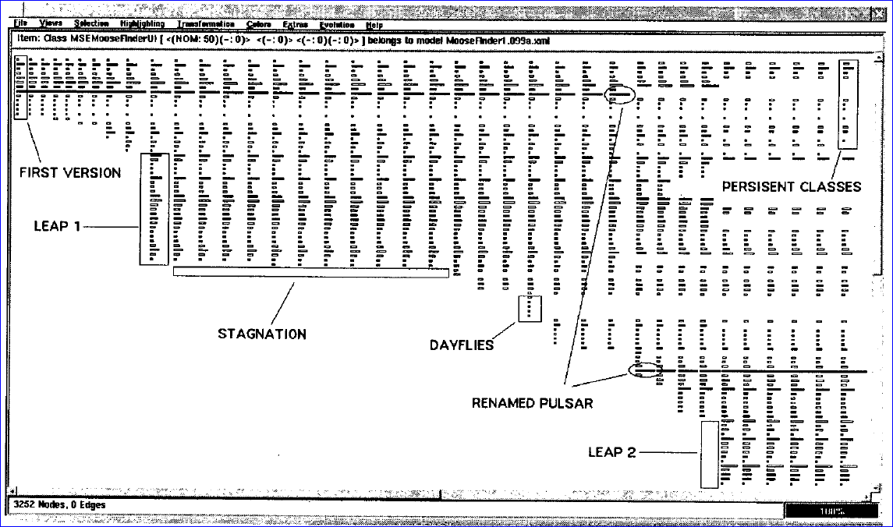
Figure 20 - The Evolution Matrix: focus on classes. Extracted from (LANZA, 2001)
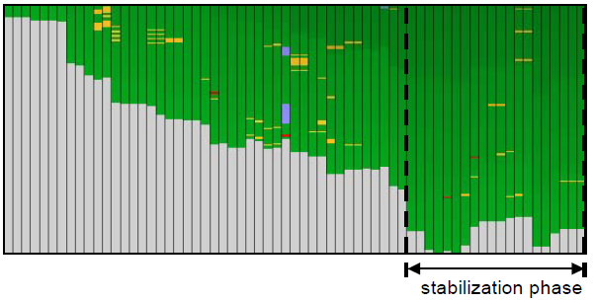
Figure 21 – CVSScan: focus on lines. Extracted from (VOINEA; TELEA; VAN WIJK, 2005)
CVSScan (VOINEA; TELEA; VAN WIJK, 2005) is a line-oriented approach that shows how a given file changed over the time, through different versions. Figure 11 shows a snapshot of the approach for a file. Each column represents a version and the rows represent lines of the file. The color scheme indicates if the line is the same (green), inserted (blue), deleted (red), or modified (yellow). Different color schemes can be chosen to depict, for example, the author of the last change in each line or the type of construct that the line represents (file reference, block, or comment).
Lifesource (GILBERT; KARAHALIOS, 2006) focus on showing how authors are contributing to a project. Figure 12 shows a visualization named CodeSaw, which shows the contributions along one year. Each colored line represents a different author and has two axes: the upper axis represents code contributions and the lower axis represents e-mail contributions to project mailing list.
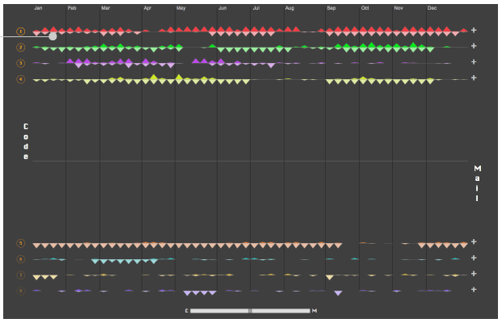
Figure 22 – LifeSource: focus on authors. Extracted from (GILBERT; KARAHALIOS, 2006)
VisGi (ELSEN, 2013), Visugit (HOZUMI, 2010), and GitHub’s Network Graph (PRESTON-WERNER, 2008) were designed to incorporate information about the different branches of a repository, using graphs to render the information.
Figure 13 shows three different repositories represented by VisGi, which uses a horizontal layout that represents time in a left-right direction. VisGi shows branches as solid black dots and branches intersections as dark gray dots.
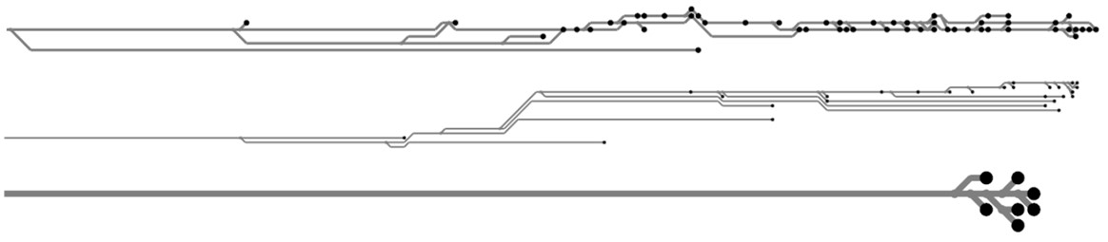
Figure 23 – VisGi: focus on branches. Extracted from (ELSEN, 2013)
Figure 14 shows a snapshot of Visugit, which shows the commits in a repository, depicting the existing branches (e.g., github/master and master).
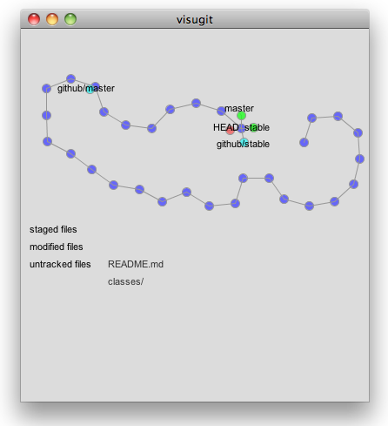
Figure 24 – Visugit: focus on branches. Extracted from (HOZUMI, 2010)
Figure 15 shows GitHub’s Network Graph, which shows all the commits associated with a repository, along with the information about branches (shown in the tag markers). The graph is drawn from the perspective of a given user (which is called root user – in this case, mojombo) and all the commits that exist in mojombo’s repository are drawn across his name. For other users, commits that exist in their repositories but not in mojombo’s are drawn across their names.
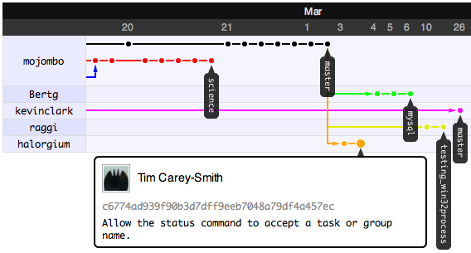
Figure 25 - GitHub’s Network Graph: focus on branches. Extracted from (PRESTON-WERNER, 2008)

Final Considerations
This chapter presented some core concepts regarding DVCS, which are essential to understand the remaining of this work. We also presented three groups of approaches related with this work.
The first group shows notifications whenever actions are performed by other developers. The approaches shown in this group do not identify related repositories and do not provide information in different levels of details, such as status, branches, and commits.
The second group comprises approaches that propose to increase the awareness of changes across different team members. Among these studies, only Crystal and FASTDash work with DVCSs, but none of them deals with repositories that pull updates from more than one peer.
In the third group, we have a number of approaches that focus on repository visualization. Most of these works were applied only to CVCSs. The only exception found were (ELSEN, 2013; HOZUMI, 2010) and (PRESTON-WERNER, 2008), which work with Git repositories, but look only at a local repository, not showing, for example, where a given commit can be found. At first sight, the work of PRESTON-WERNER seems to address this topic, but it actually shows commits that a peer has and the root user does not, but a given commit could not exist in the root user and exist in other repositories, which we cannot depict in their visualization.
Lastly, it is worth noticing that we could not find any similar work showing the dependencies among several clones of a DVCS.

Bibliography
APPLETON, B.; BERCZUK, S.; CABRERA, R.; ORENSTEIN, R. Streamed lines: Branching patterns for parallel software development. PLoP 1998, aug. 1998, Monticello, Illinois, USA: ACM, aug. 1998.
BIEHL, J. T.; CZERWINSKI, M.; SMITH, G.; ROBERTSON, G. G. FASTDash: A Visual Dashboard for Fostering Awareness in Software Teams. CHI ’07, 2007, New York, NY, USA: ACM, 2007. p. 1313–1322. . Accessed: 3 may 2014.
BRUN, Y.; HOLMES, R.; ERNST, M. D.; NOTKIN, D. Proactive detection of collaboration conflicts. ESEC/FSE ’11, sep. 2011, New York, NY, USA: ACM, sep. 2011. p. 168–178.
COLLBERG, C.; KOBOUROV, S.; NAGRA, J.; PITTS, J.; WAMPLER, K. A System for Graph-based Visualization of the Evolution of Software. SoftVis ’03, 2003, New York, NY, USA: ACM, 2003. p. 77–ff. . Accessed: 4 may 2014.
DA SILVA, I. A.; CHEN, P. H.; VAN DER WESTHUIZEN, C.; RIPLEY, R. M.; VAN DER HOEK, A. Lighthouse: coordination through emerging design. eclipse ’06, oct. 2006, New York, NY, USA: ACM, oct. 2006. p. 11–15.
DEWAN, P.; HEGDE, R. Semi-synchronous conflict detection and resolution in asynchronous software development. ECSCW 2007, sep. 2007, Limerick, Ireland: Springer London, sep. 2007. p. 159–178.
DIEHL, S. Software Visualization: Visualizing the Structure, Behaviour, and Evolution of Software. 2007 edition ed. Berlin ; New York: Springer, 2007.
DOURISH, P.; BELLOTTI, V. Awareness and Coordination in Shared Workspaces. CSCW ’92, 1992, New York, NY, USA: ACM, 1992. p. 107–114. . Accessed: 5 mar. 2014.
ELSEN, S. VisGi: Visualizing Git branches. In: 2013 FIRST IEEE WORKING CONFERENCE ON SOFTWARE VISUALIZATION (VISSOFT), sep. 2013, Eindhoven, Netherlands: IEEE, sep. 2013. p. 1–4.
ESTUBLIER, J. Software configuration management: a roadmap. ICSE ’00, may 2000, New York, NY, USA: ACM, may 2000. p. 279–289.
FITZPATRICK, G.; MARSHALL, P.; PHILLIPS, A. CVS Integration with Notification and Chat: Lightweight Software Team Collaboration. CSCW ’06, 2006, New York, NY, USA: ACM, 2006. p. 49–58. . Accessed: 24 jun. 2014.
FUKS, H.; RAPOSO, A.; GEROSA, M. A.; PIMENTEL, M.; LUCENA, C. J. The 3c collaboration model. In: KOCK, N. (Org.). The Encyclopedia of E-Collaboration. New York, NY, USA: Information Science Reference, 2007. p. 637–644.
GILBERT, E.; KARAHALIOS, K. LifeSource: Two CVS Visualizations. CHI EA ’06, 2006, New York, NY, USA: ACM, 2006. p. 791–796. . Accessed: 4 may 2014.
GOODMAN, L. A. Snowball Sampling. The Annals of Mathematical Statistics, MR: MR124140Zbl: 0099.14203, v. 32, n. 1, p. 148–170, mar. 1961. Accessed: 31 jul. 2014.
GUIMARÃES, M. L.; SILVA, A. R. Improving early detection of software merge conflicts. ICSE 2012, jun. 2012, Piscataway, NJ, USA: IEEE Press, jun. 2012. p. 342–352.
GUTWIN, C.; GREENBERG, S.; ROSEMAN, M. Workspace Awareness in Real-Time Distributed Groupware: Framework, Widgets, and Evaluation - Springer. In: SASSE, M. A.; CUNNINGHAM, R. J.; WINDER, R. L. (Org.). People and Computers XI. London: Springer London, 1996. p. 281–298. . Accessed: 22 jun. 2014.
HOZUMI, T. Visugit. Available: <https://github.com/hozumi/visugit>. Accessed: 4 may 2014.
LANZA, M. The Evolution Matrix: Recovering Software Evolution Using Software Visualization Techniques. IWPSE ’01, 2001, New York, NY, USA: ACM, 2001. p. 37–42. . Accessed: 15 feb. 2014.
LEON, A. Software Configuration Management Handbook, Second Edition. 2. ed. Norwood, MA, USA: Artech House, 2004.
MURTA, L. G. P. Gerência de Configuração no Desenvolvimento Baseado em Componentes. 2006. 213 f. UFRJ, COPPE, Rio de Janeiro, Brasil, 2006.
PRESTON-WERNER, T. GitHub’s Network Graph. Available: <https://github.com/blog/39-say-hello-to-the-network-graph-visualizer>. Accessed: 16 feb. 2014.
ROCHKIND, M. J. The source code control system. IEEE Transactions on Software Engineering. (TSE), v. 1, n. 4, p. 364–470, dec. 1975. Accessed: 28 aug. 2012.
SARMA, A.; REDMILES, D. F.; VAN DER HOEK, A. Palantir: Early Detection of Development Conflicts Arising from Parallel Code Changes. IEEE Transactions on Software Engineering, v. 38, n. 4, p. 889 –908, aug. 2012.
STEINMACHER, I.; CHAVES, A.; GEROSA, M. Awareness Support in Distributed Software Development: A Systematic Review and Mapping of the Literature. Computer Supported Cooperative Work (CSCW), p. 1–46, may 2012. Accessed: 14 oct. 2012.
VOINEA, L.; TELEA, A.; VAN WIJK, J. J. CVSscan: Visualization of Code Evolution. SoftVis ’05, 2005, New York, NY, USA: ACM, 2005. p. 47–56. . Accessed: 23 apr. 2014.

Here we focus on the possibility of breaking a pull into two different commands, but keep in mind that different tools can have different commands to do the same operation. An example is the pull command. Whereas in Git it brings the changes and applies them to the workspace, in Mercurial it only brings the changes and we have to perform an update command to apply them. Later versions of Mercurial are being distributed with a fetch extension, which brings the changes and applies them. This way, the pull command in Git is equivalent to the fetch command in Mercurial, and vice-versa. Whenever we mention any command herein, we will be expecting the behavior provided by Git.
A compilation of branching patterns to address different needs can be found in (APPLETON et al., 1998).
http://svnnotifier.tigris.org/ (2012)
https://github.com/pocorall/scm-notifier (2012)
http://tools.tortoisesvn.net/CommitMonitor.html (2013)
http://code.google.com/p/svnradar/ (2011)
http://www.fsmpi.uni-bayreuth.de/~dun3/hg-commit-monitor (2009)
http://www.visualstudio.com/en-us/products/tfs-overview-vs.aspx (2013)

